Chapter 4, Solution 97.

A common-emitter amplifier circuit is shown in Fig. 4.152. Obtain the Thevenin equivalent to the left of points B and E.

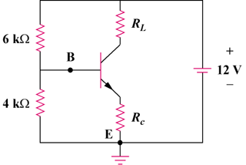

Figure 4.152
For Prob. 4.97.

Solution

+

V_{Th}

−

12V

+
−

4 kΩ

E

6 kΩ

B

R_{Th} = R₁||R₂ = 6||4 = 2.4 k ohms

V_{Th} = [R₂/(R₁ + R₂)]v_{s} = [4/(6 + 4)](12) = 4.8 V

